**PCB Design Report**

1. **Rules and Validations**

After concluding our simulation report and feedback session, we have made some corrections on component selection and schematic design, which is discussed above, then we moved into PCB design part. As we stated before, our main idea is to have a compact, reliable, adjustable and high power dense electronic card, so we have counted these features during design process.

In this project, we have used Altium Designer 20, and our design has two layers, and both layer includes components. Before starting our design, we have determined the design rules to have a reliable and safe card, which can be seen in figure-1. However, for medium voltages (150-300V), according to IPC2221A, clearance between lines should be minimum 1.25mm, for our medium voltage tracks (rectifier), we have used that minimum value. For 15V and 30V range, this spacing should be minimum 0.25mm, where our clearance rule satisfies that value.

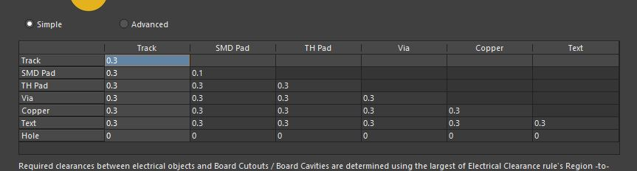

**Figure 1:** PCB Design Rule (Clearance)

From simulations, we have seen that, in rectifier and and buck converter, we have a maximum 2.5A current, and our lines and vias should satisfy this value. For rectifier and buck converter lines, we used fixed 0.8mm line width, and minimum 0.6mm via hole, 1,2mm via pad to stay in safe zone. For other low current lines, we have used various line width between 0.3mm and 0.5mm, and we used fixed via dimensions which are 0.4mm hole and 0.8mm pad. We have validated rectifier line and via ratings from Saturn PCB Toolkit, which can be seen in figure 2 and 3 respectively.

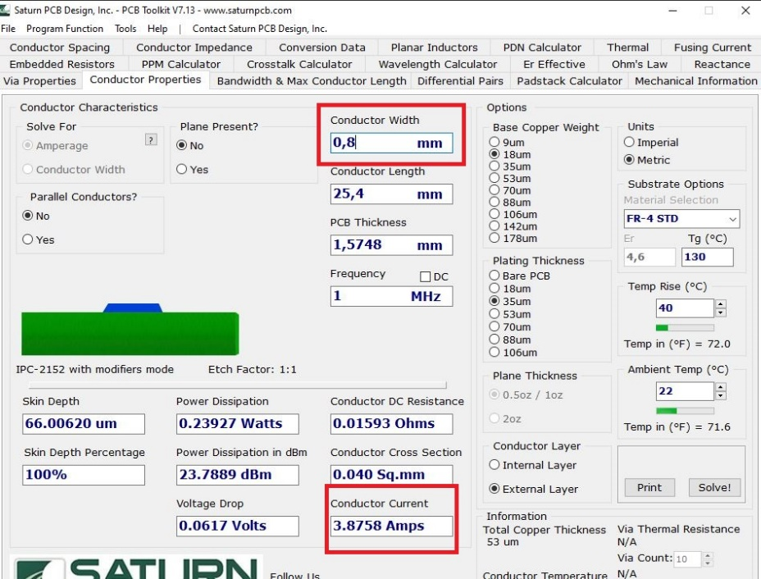

**Figure 2:** Line Current Validation

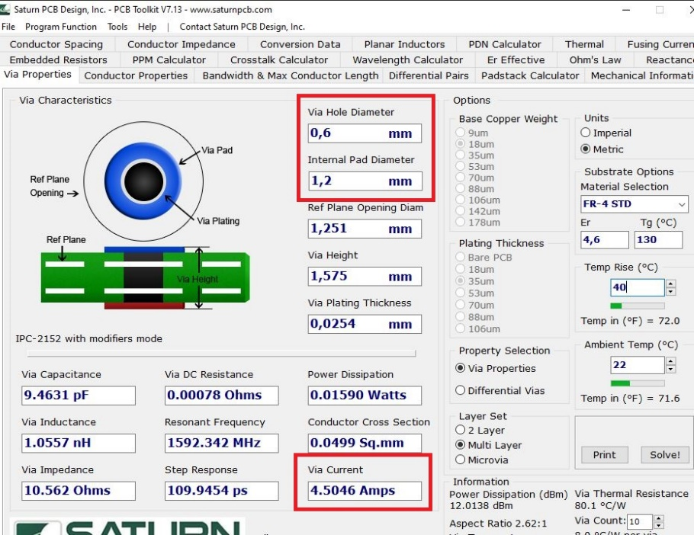

**Figure 3:** Via Current Validation

After finalizing our rules and getting validation for our pre-design about lines and vias, we have constructed our PCB design, and when we finalized that design, we used the Design Rule Check of Altium Designer, to see violations and connection problems. And finally, we have achieved a card without any error, which can be seen in figure-4.

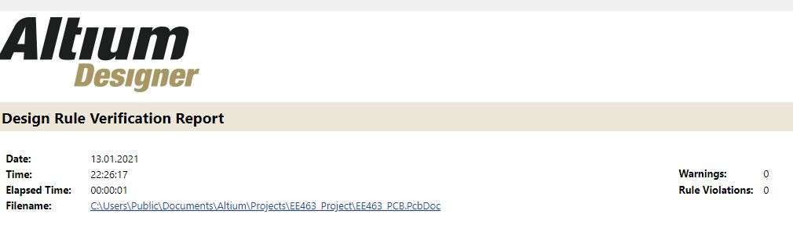

**Figure 4:** Design Rule Check

1. **2D Design**